PRACTICAL NO. 07

7. Layer 2 Security
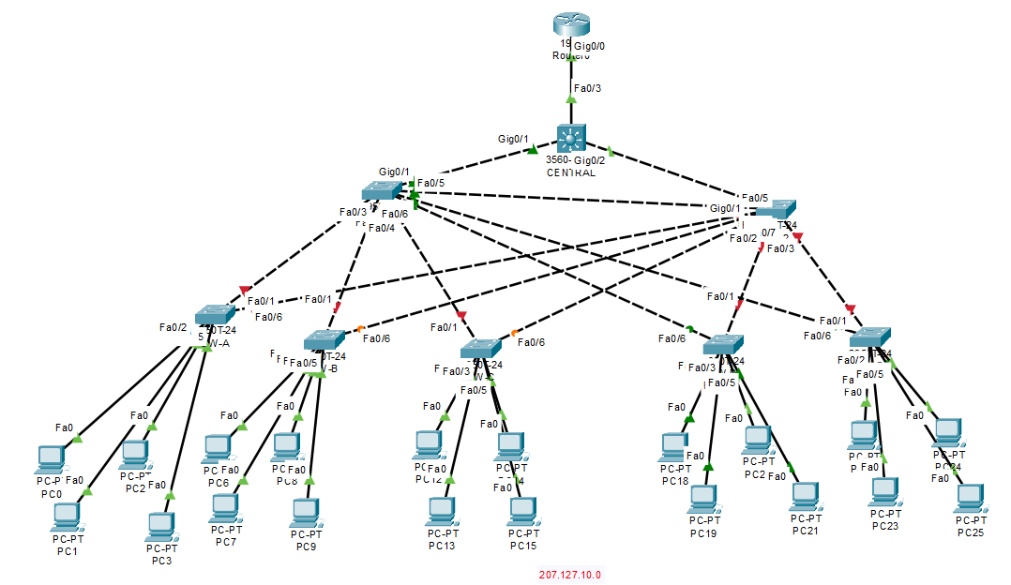
Assign Primary root to a Central switch :
Showing all spanning tree :
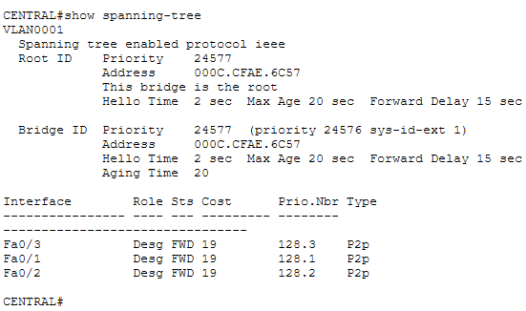

Enable PortFast on all access ports.

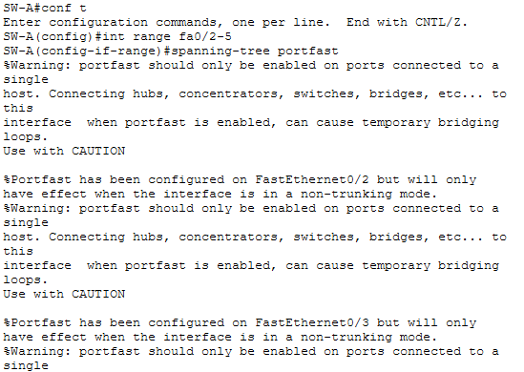

Enable BPDU guard on all access ports

Enable root guard on SW-1 and SW-2
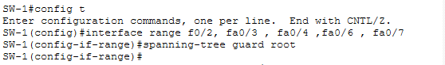

Configure basic port security on all ports connected to host devices.
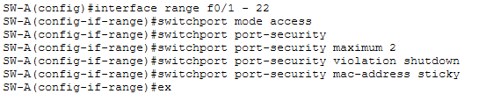
Disable unused ports.
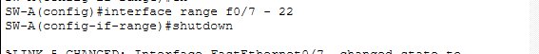

verify that port security has been configured on SW-A before sending packet from PC0 to PC1.
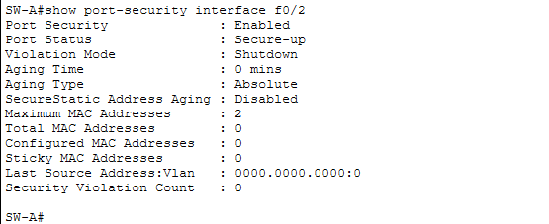

After Ping from PC0 to PC1
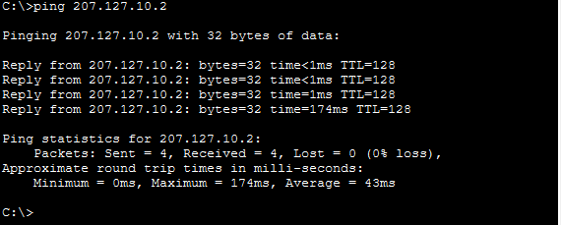

verify that port security has been configured on SW-A after sending packet from PC0 to PC1.
